Disadvantages of Reverse Osmosis

- The reverse osmosis process is not ion selective (removal of all ions, not just unwanted). Water removes missing ions from human body draining it and could create potential health risk.
- the reverse osmosis membranes concentrate the contaminants, which then require disposal
- RO units use a lot of water. They recover only 5 to 15 percent of the water entering the system. The remainder is discharged as waste water. Because waste water carries with it the rejected contaminants, methods to re-cover this water are not practical for household systems. Waste water is typically connected to the house drains and will add to the load on the household septic system. An RO unit delivering 5 gallons of treated water per day may discharge 40 to 90 gallons of waste water per day to the septic system
- Influent water may require prior treatment before entering the reverse osmosis system
- The pH of incoming water is recommended to be 4.0, which often requires the addition of large quantities of sulfuric acid, sequestering agents and cleaning agents to the influent water
- Additives in themselves require special handling and containment considerations.
- A serious problem for the reverse osmosis process is membrane fouling. Clogging may occur when high levels of harmless minerals, such as calcium and magnesium are present. Regular membrane replacement is needed.

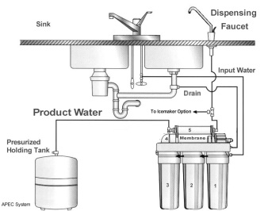

Water's Chemical Properties

- You probably know water's chemical description is H2O. As the diagram shows, that is one atom of oxygen bound to two atoms of hydrogen. The hydrogen atoms are "attached" to one side of the oxygen atom, resulting in a water molecule having a positive charge on the side where the hydrogen atoms are and a negative charge on the other side, where the oxygen atom is. Since opposite electrical charges attract, water molecules tend to attract each other, making water kind of "sticky
- All these water molecules attracting each other mean they tend to clump together. This is why water drops are, in fact, drops! If it wasn't for some of Earth's forces, such as gravity, a drop of water would be ball shaped -- a perfect sphere. Even if it doesn't form a perfect sphere on Earth, we should be happy water is sticky.
- Water is called the "universal solvent" because it dissolves more substances than any other liquid. This means that wherever water goes, either through the ground or through our bodies, it takes along valuable chemicals, minerals, and nutrients.
- Pure water has a neutral pH of 7, which is neither acidic nor basic.

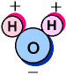

pH

- pH is a measure of how acidic/basic water is. The range goes from 0 - 14, with 7 being neutral. pHs of less than 7 indicate acidity, whereas a pH of greater than 7 indicates a base. pH is really a measure of the relative amount of free hydrogen and hydroxyl ions in the water. Water that has more free hydrogen ions is acidic, whereas water that has more free hydroxyl ions is basic. Since pH can be affected by chemicals in the water, pH is an important indicator of water that is changing chemically. pH is reported in "logarithmic units," like the Richter scale, which measures earthquakes. Each number represents a 10-fold change in the acidity/basicness of the water. Water with a pH of 5 is ten times more acidic than water having a pH of six.
- Pollution can change a water's pH, which in turn can harm animals and plants living in the water. For instance, water coming out of an abandoned coal mine can have a pH of 2, which is very acidic and would definitely affect any fish crazy enough to try to live in it! By using the logarithm scale, this mine-drainage water would be 100,000 times more acidic than neutral water -- so stay out of abandoned mines.

